W6. HW3. Advance SQL-III (Questions)

Due date: October 2, 11:59 pm
Submission Guidelines:
- Dataset: You must use the provided IMDB.sqlite dataset to answer all questions.
- Code and Output: Copy your code and attach screenshots of your outputs under each question.
- Submission Format: Each student is required to push one Word or PDF file to the designated GitHub repository created specifically for this week’s assignment.
- Repository Name: Use the format Week 6-HW3-LastName, where LastName is your last name.
- Code Quality: Ensure your code is well-commented and organized for easy understanding.

1. Directors with More Movies Than the Average
Find directors who have directed more movies than the average number of movies directed by all directors. Display their name and the number of movies they directed.
Code:
WITH DirectorMovieCounts AS (
SELECT
d.id,
d.name,
COUNT(m.id) AS num_movies
FROM directors d
JOIN movies m ON d.id = m.director_id
GROUP BY d.id, d.name
)
SELECT
name,
num_movies
FROM DirectorMovieCounts
WHERE num_movies > (
SELECT AVG(num_movies)
FROM DirectorMovieCounts
)
ORDER BY name ASC;
Result:
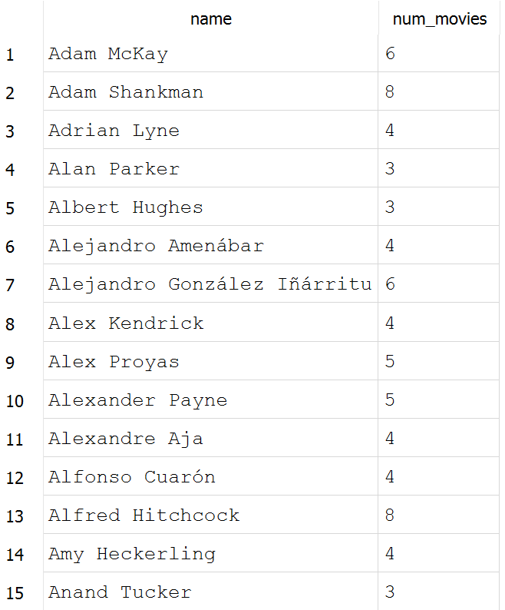

2. Find Directors with Total Revenue Above the Average Revenue of All Directors
Retrieve the names of directors whose total revenue from their movies is greater than the average total revenue of all directors.
Code:
WITH DirectorRevenues AS (
SELECT
d.id,
d.name,
SUM(m.revenue) AS total_revenue
FROM directors d
JOIN movies m ON d.id = m.director_id
GROUP BY d.id, d.name
)
SELECT
name,
total_revenue
FROM DirectorRevenues
WHERE total_revenue > (
SELECT AVG(total_revenue)
FROM DirectorRevenues
)
ORDER BY name ASC;

Results:

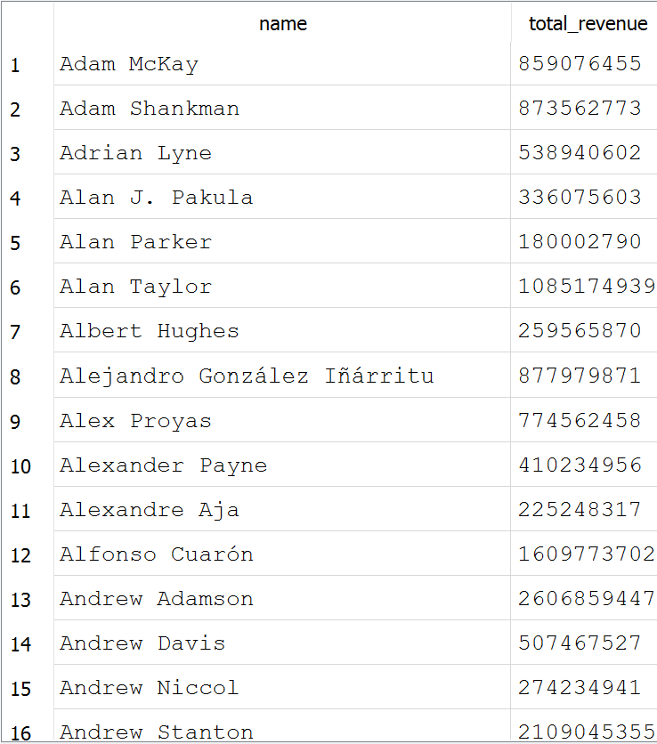

3.Movies with Revenue Higher than the Average Revenue of All Movies Released in the List the titles of movies whose revenue is greater than the average revenue of all movies released in the same year. Include the title, year, and revenue.
Code:
WITH YearlyAvgRevenue AS (
SELECT
strftime('%Y', release_date) AS release_year, -- or cast(substr(release_date, 1, 4) as integer) depending on date storage format
AVG(revenue) AS avg_revenue
FROM movies
WHERE release_date IS NOT NULL AND revenue IS NOT NULL
GROUP BY strftime('%Y', release_date)
)
SELECT
m.title,
strftime('%Y', m.release_date) AS release_year,
m.revenue
FROM movies m
JOIN YearlyAvgRevenue y
ON strftime('%Y', m.release_date) = y.release_year
WHERE m.revenue > y.avg_revenue
ORDER BY m.id ASC;

Results:
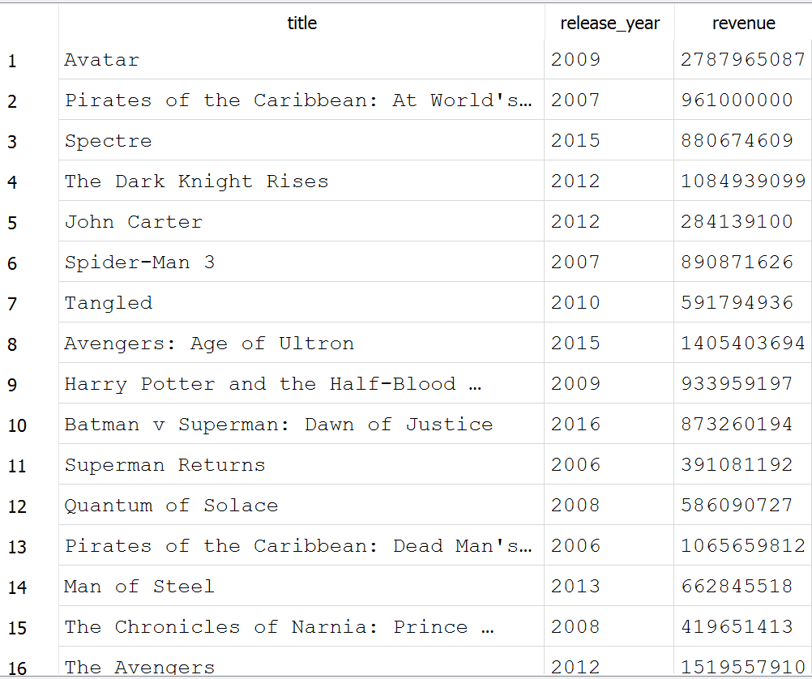

4. For movies released after the year 2000, display the year and the minimum revenue generated in that year for movies with more than 10 votes. Exclude years where the minimum revenue was 0.

Code:
SELECT
CAST(strftime('%Y', release_date) AS INTEGER) AS year,
MIN(revenue) AS min_revenue
FROM movies
WHERE CAST(strftime('%Y', release_date) AS INTEGER) > 2000
AND vote_count > 10
AND revenue > 0
GROUP BY year
HAVING min_revenue > 0
ORDER BY year ASC;

Results:

